## 2022 Fuel Consumption Ratings

**Dataset link -** <https://www.kaggle.com/datasets/rinichristy/2022-fuel-consumption-ratings>

**Dashboard link -** [2022 Fuel Consumption Ratings Dashboard | Tableau Public](https://public.tableau.com/app/profile/ashish.anand4858/viz/2022FuelConsumptionRatingsDashboard/CO2RatingandSmogRatingbyModel?publish=yes)

**Visual 1 -** CO2 Rating and Smog Rating by Model

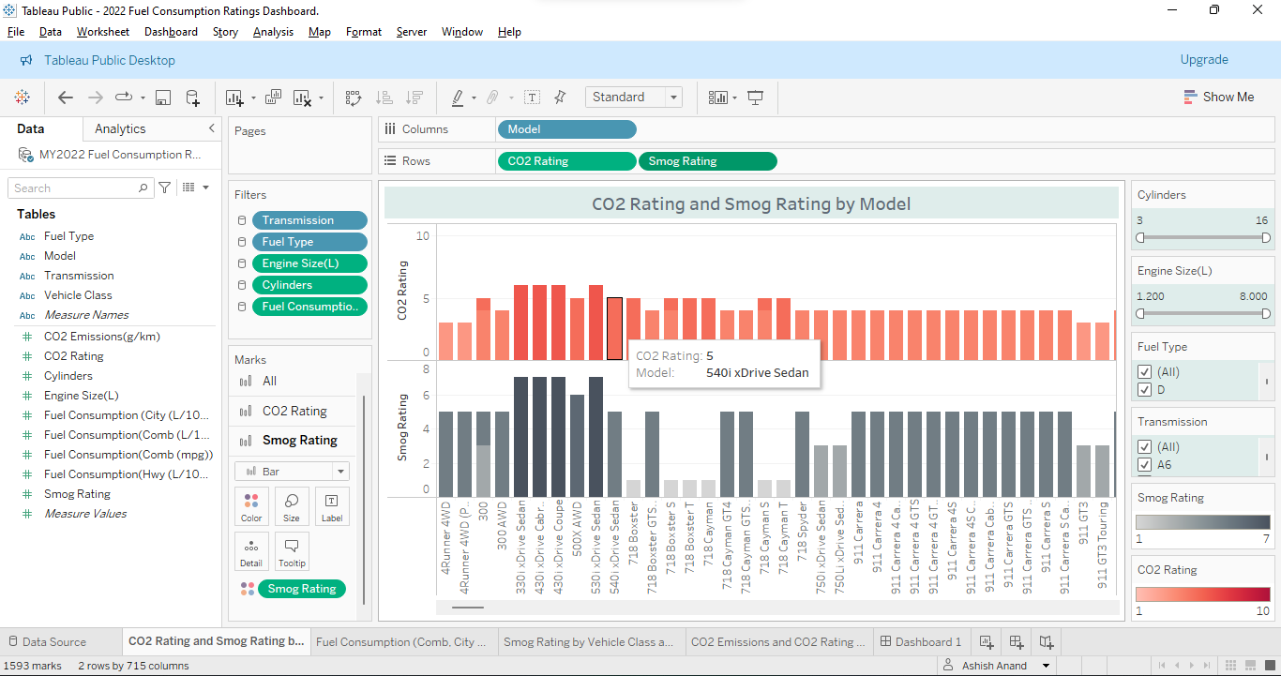

**Visual 2 -** Fuel Consumption (Comb, City & Hwy ) (L/100 km) by Models

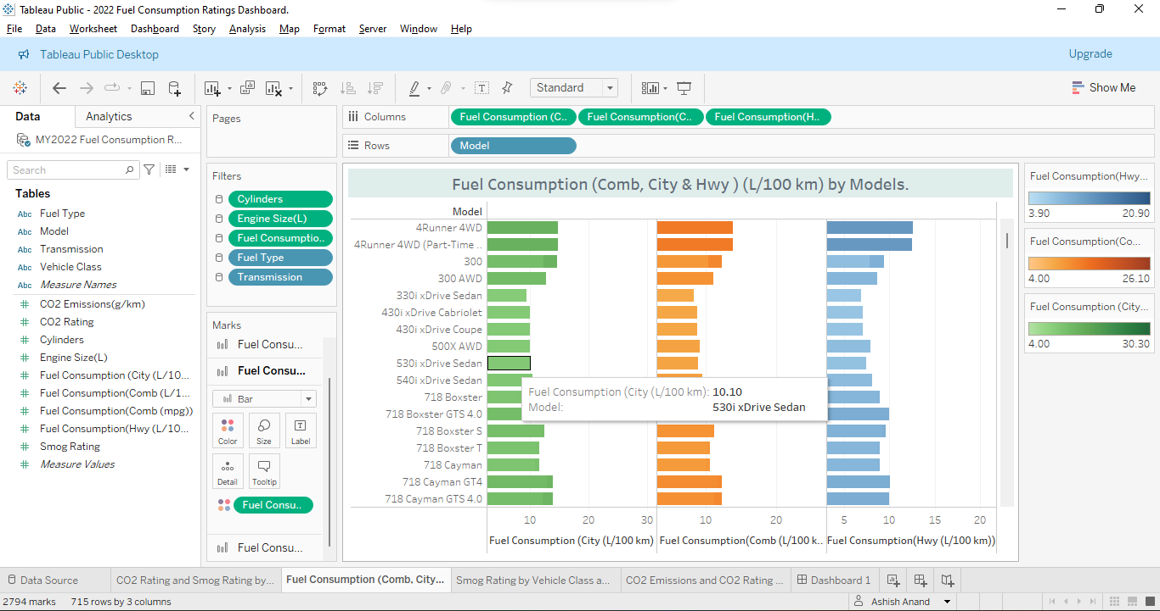

**Visual 3** - Smog Rating by Vehicle Class and Models

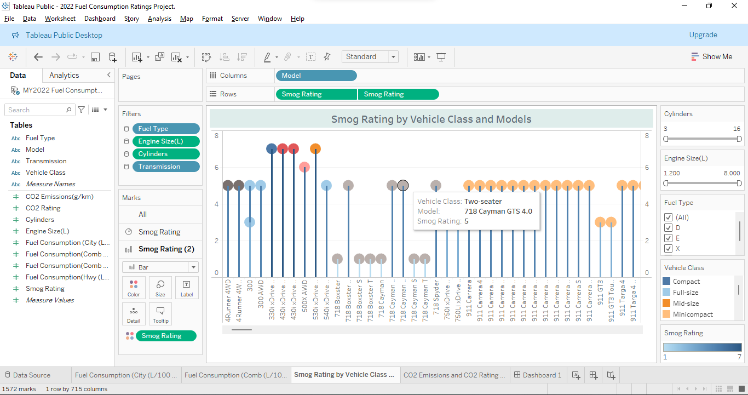

**Visual 4** - CO2 Emissions and CO2 Rating by Models

